
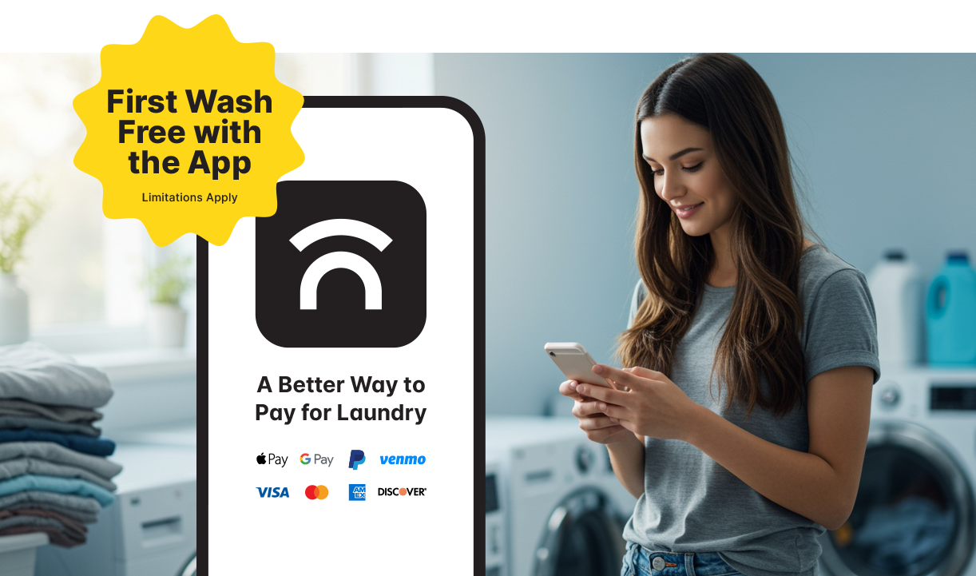
Get started with One Tap Away
Download now – your first free wash is waiting!
Your laundry rooms were just upgraded to One Tap Away for an enhanced laundry experience. Here are some useful tips on how to get started with the mobile app. Plus, your first wash is free!
- Download One Tap Away App
  - Find it in the App Store or Google Play
  - Or scan the QR code in your laundry room
- Create your Account
  - Enter your personal information & phone number
  - Check your email or text messages and enter the verification code
- Enable Permission
  - Allow Bluetooth and notifications in order to pay for machines, check machine availability and receive updates on your laundry cycles
- Connect to a Machine
  - Once in the laundry room... tap “Scan Machine” to scan the QR code, or tap “CSC Laundry” to see available washers and dryers
  - Select your cycle and press START on the machine

Download the App Now

With One Tap Away, you can:
- See which machines are available
- Pay for laundry with your phone
- Easily request refunds or service requests
- Get real-time updates when your cycle is done
- Explore Marketplace for deals and discounts on everyday goods and services
Get Washing

Learn more about the app benefits on this flyer, or visit getonetapaway.com for more info on how to transfer existing laundry funds and FAQs.

Need More Help?
You can use the chat feature in the app by tapping 'Chat' or feel free to email us at otasupport@cscsw.com or call 844-272-9675.

