
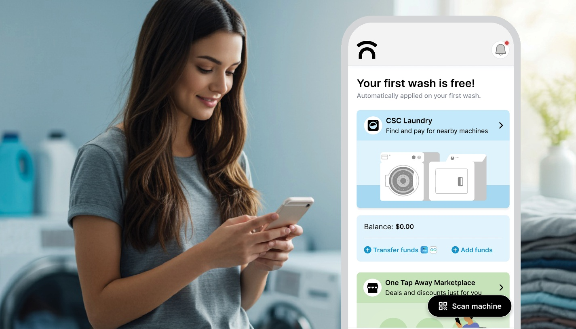
Get started with One Tap Away
Download now – your free wash is just one tap away!
If you haven’t yet downloaded the One Tap Away app for laundry, here are some useful tips on how to get started. Plus, your first wash is free!
- Download One Tap Away App
  - Find it in the App Store or Google Play
  - Or scan the QR code in your laundry room
- Create your Account
  - Enter your personal information & phone number
  - Check your email or text messages and enter the verification code
- Enable Permission
  - Allow Bluetooth, location, and notifications in order to find nearby machines and receive updates on laundry cycles
- Connect to a Machine
  - Once in the laundry room... tap “Scan Machine” to scan the QR code, or tap “CSC Laundry” to pick a washer or dryer
  - Select your cycle and press START on the machine

Download the App Now

With One Tap Away, you can:
- See which machines are available
- Pay for laundry with your phone
- Easily request refunds or service requests
- Get real-time updates when your cycle is done
- Explore Marketplace for deals and discounts on everyday goods and services
Get Washing

Need More Help?
You can use the chat feature in the app by tapping 'Chat' or feel free to email us at [email protected] or call 844-272-9675.

