
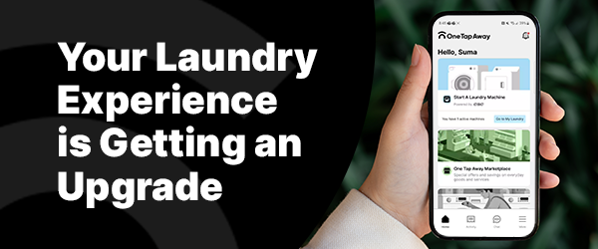
Your laundry room will transition to the One Tap Away app. This upgrade brings an enhanced, user-friendly experience, including the ability to access deals and discounts through the OTA Marketplace. If you currently use a laundry card, it will no longer work with the new system so please follow the steps here to use up or redeem your balance.
To help get you started, your first wash with the app is free!
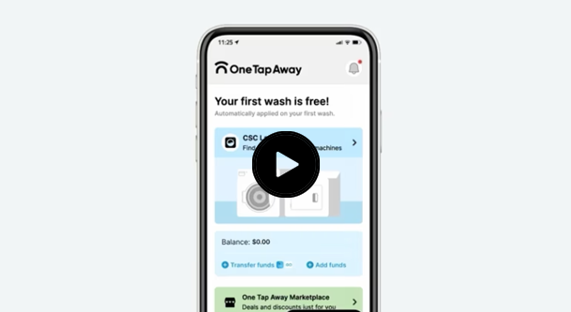
FAQs to Help You Prepare:
How do I add money to my account?
Go to ‘More,’ click ‘Wallet,’ and select ‘Add Funds.’
What payment methods can I use?
One Tap Away accepts all major credit cards, Apple Pay, Google Pay, PayPal, Venmo, and more!
Is my credit card transaction secure?
Yes, the app complies with PCI standards for secure transactions.
For additional questions or assistance
Visit our Resident Landing Page or contact us at 844-272-9675.
Download the App Now
Best regards,
The CSC ServiceWorks Team

