
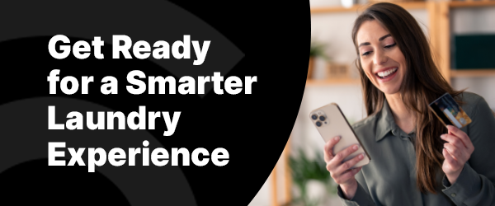

We’re excited to announce that your laundry room is being upgraded! Soon, you’ll enjoy a smarter, more convenient way to do laundry with the One Tap Away Mobile app. Please follow the steps below in advance of this upgrade to ensure a smooth transition.
If you currently use a CSC laundry card:
- Please try to deplete your laundry card balance before the upgrade.
- If you have a remaining balance after the upgrade, download or request a balance transfer form from your property manager.
- Mail the completed form and your laundry card to the address on the form for a refund.
- Download the One Tap Away Mobile app for free on iOS or Android and enjoy your first wash free!

If you currently use an ESD laundry card:
- You can continue using your ESD card until your balance is used up.
- After the upgrade, download the One Tap Away app for free on iOS or Android.
- Enjoy a free wash when you use the app to replace any leftover balance below a vend price.

 | You’ll Love One Tap Away:  - No more coins or cards—pay digitally through the app.  - Check machine availability and receive cycle notifications.  - Access exclusive deals on everyday  goods and services through the OTA Marketplace.

Visit our Resident Resource Page for more information and access step-by-step
instructions to prepare for the upgrade.

If you have any questions or need assistance, please contact your property manager
or call 844-272-9675.

Download the App Now

Best regards,
The CSC ServiceWorks Team

